CS 306 ‘Library Management’ Project Step 5 - Support Page

Emir Asal 27933

For the last step, support page is created for both client and admin so that they can communicate if the client has a problem with anything.
NoSQL Firebase, Realtime Database is used to store the messages. Both messages can be seen from the admin and client side if a new message is sent page is automatically refreshed.
https://cs306-step5-e6b41-default-rtdb.europe-west1.firebasedatabase.app

Client Support Page can be accessed from the main page of the website, it is located at the right most bottom. Message will be sent to the NoSQL database with the current date and the sender info which is “client” in this case.
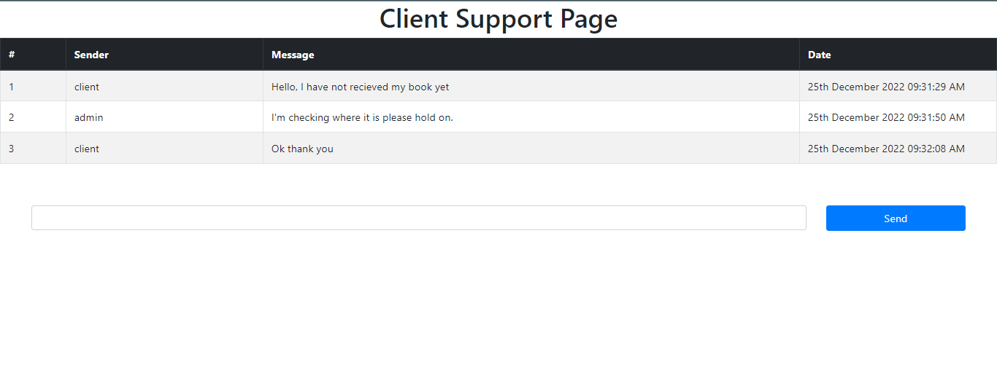

Support Page for admin can be accessed from the bottom of the admin panel. Admin can see every message that was sent by both client and admin same as client support page. Only difference is that the messages that are sent from this page will contain the sender information “admin”.
